**PRJ301 Assignment**

**Project name: Gucci Shoes**

***Team member:***

1. Trần Phạm Gia Bảo – SE140647
2. Nguyễn Phạm Đăng Khoa – SE140662
3. Lý Định Công Minh – SE140952

***Spring 2021***

# Case Study

Currently, there are many young people who need to study online to save time and money on online websites. Therefore, developing a system of online shop is essential to provide users with more choice and convenience in product selection, and this website gives you a better overview of online shopping and searching the product is suitable for you.

# Database Design

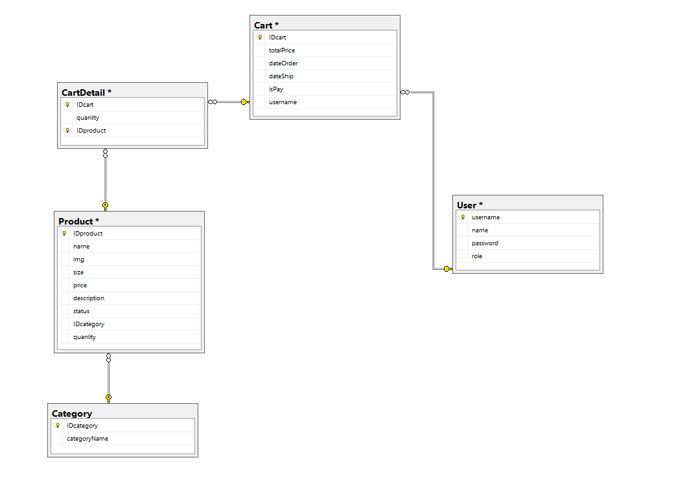

**Database Diagram**

# System Design

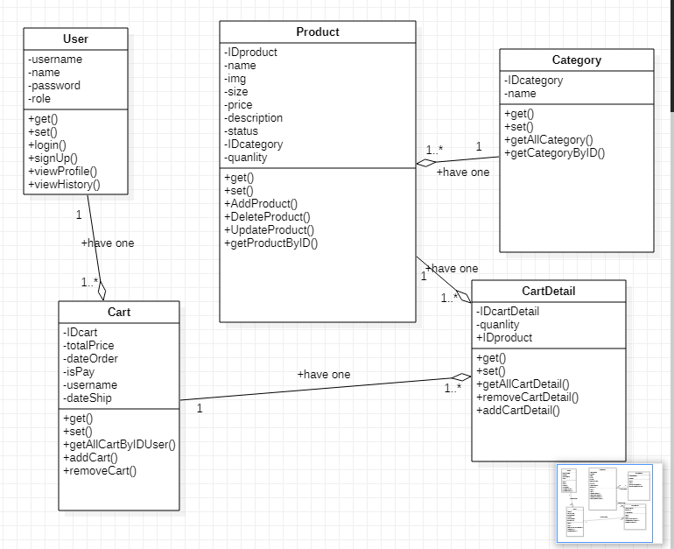

**Class Diagram**

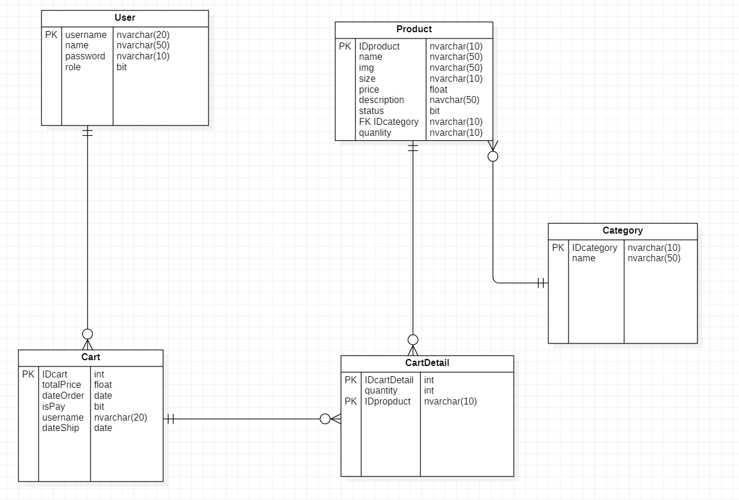

**Entity Relationship Diagram**

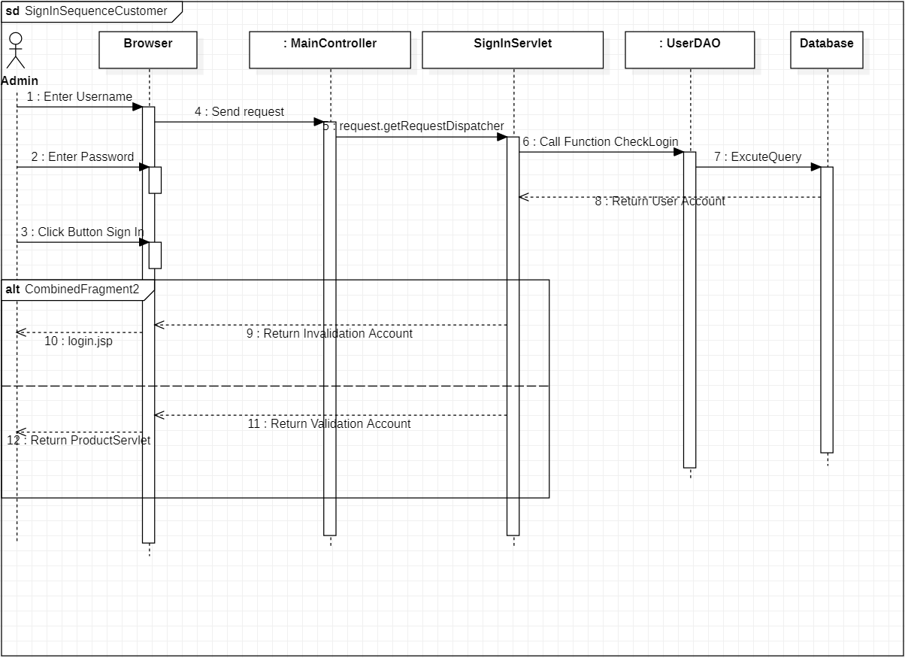

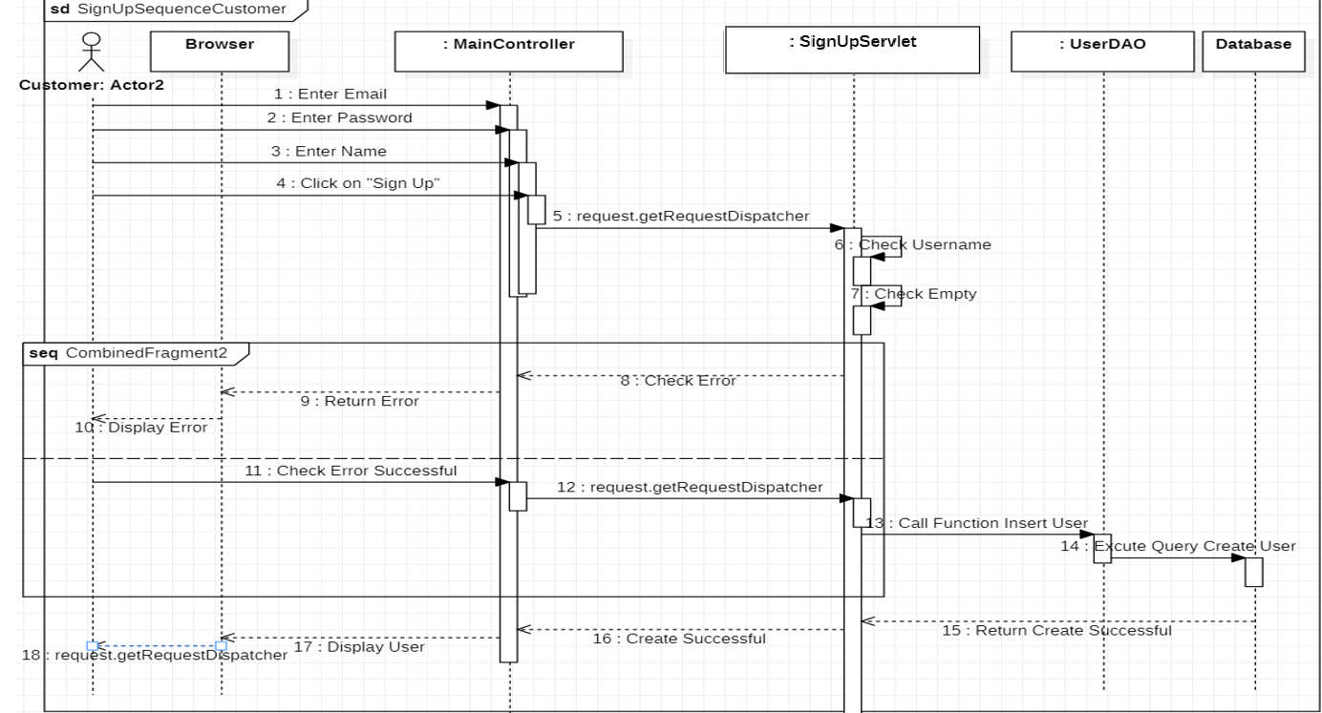

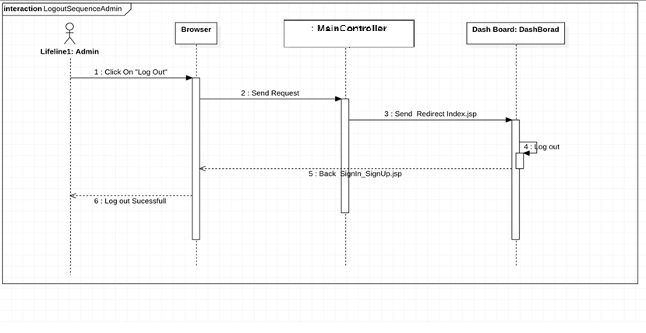

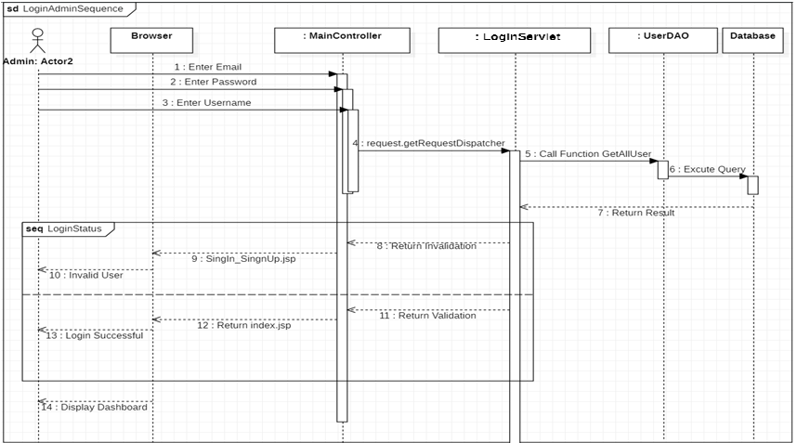

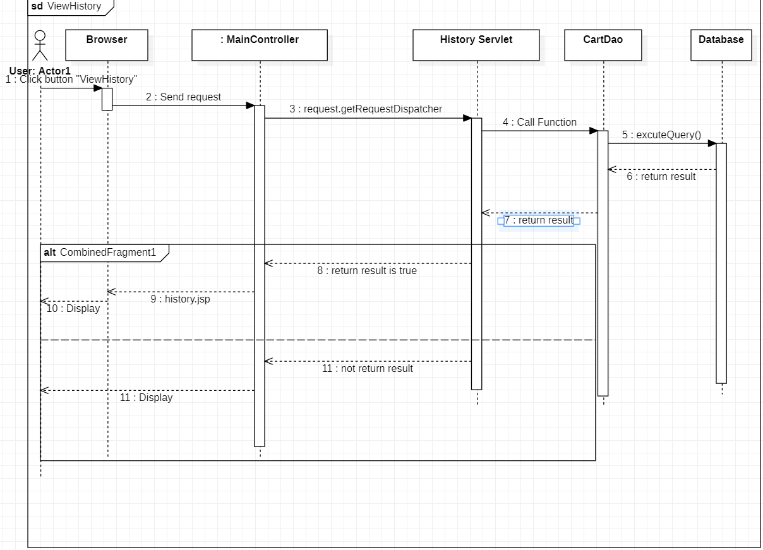

# Implementation (Screenshot with explanation)

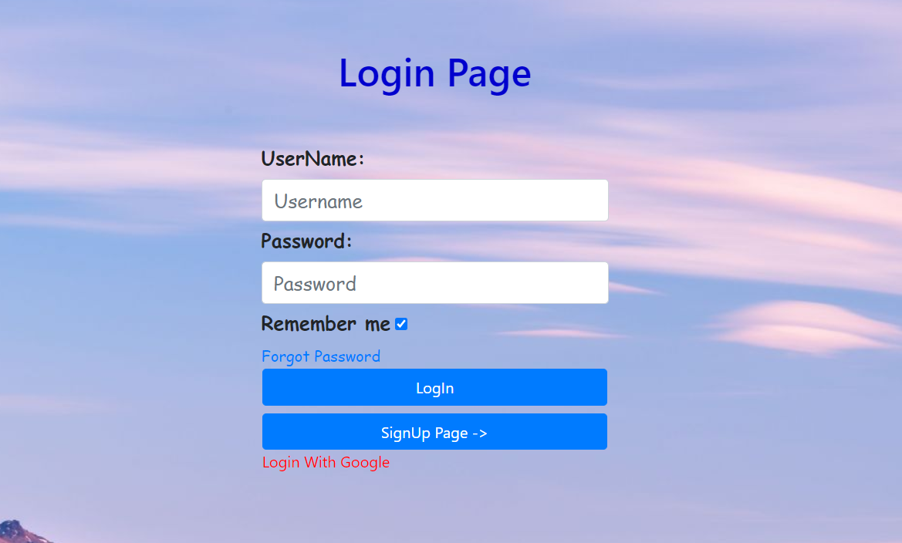

**Login Page**

* User can login with username or password ( signed up )
* User also can login with Google account
* Check validation if username or password is empty

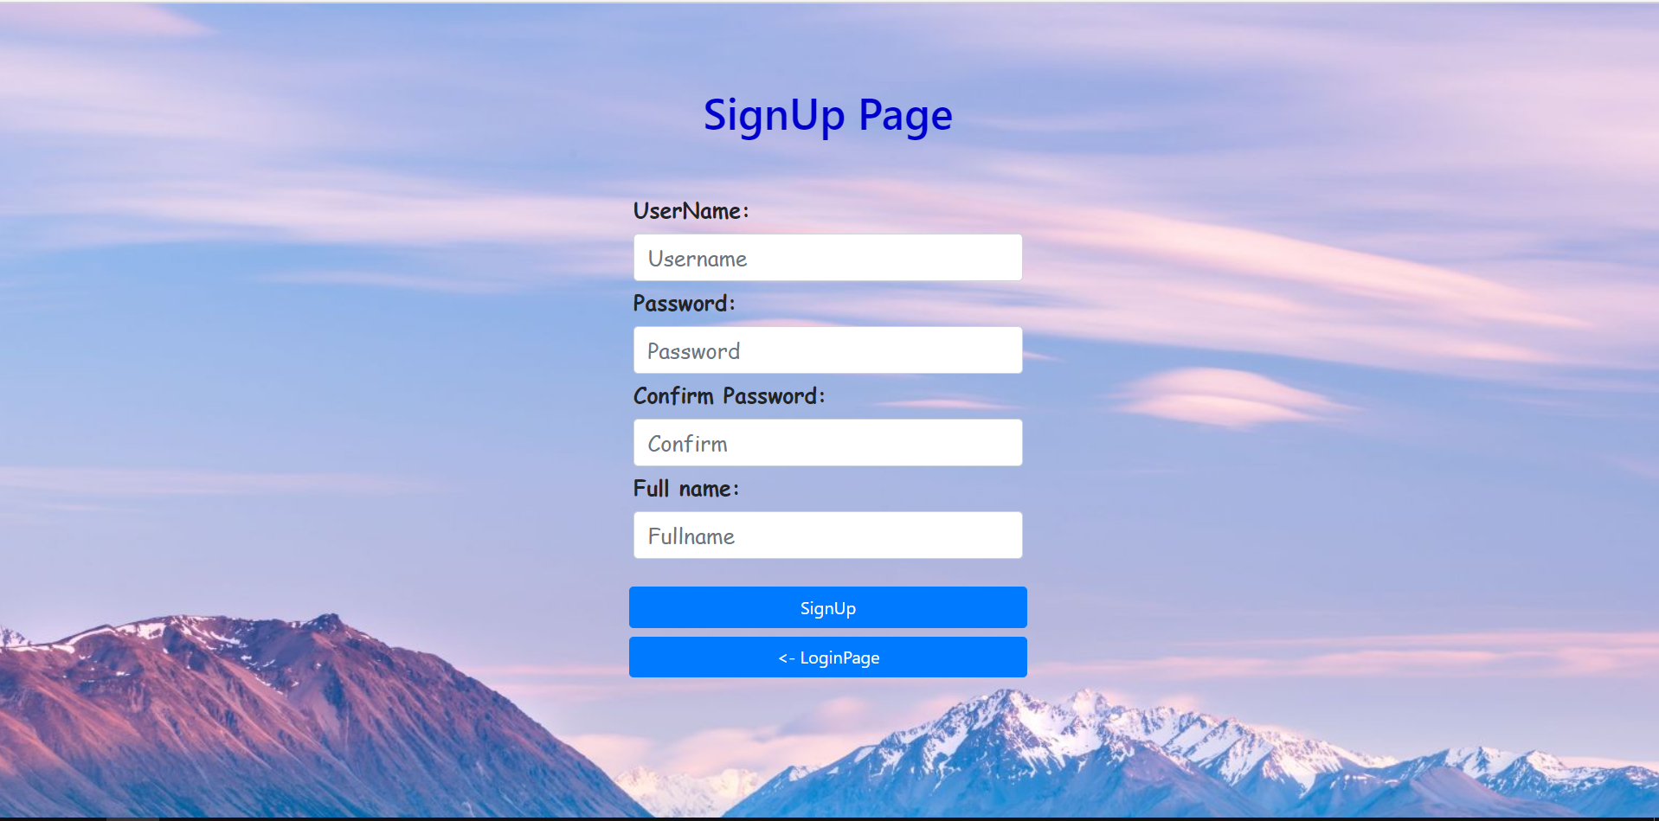

**SignUp Page**

* User input UserName, Password, ConfirmPassword, Full Name to Create New Account on our website
* Check validation if user disclaims no data entry
* User can back to LoginPage if they have account before

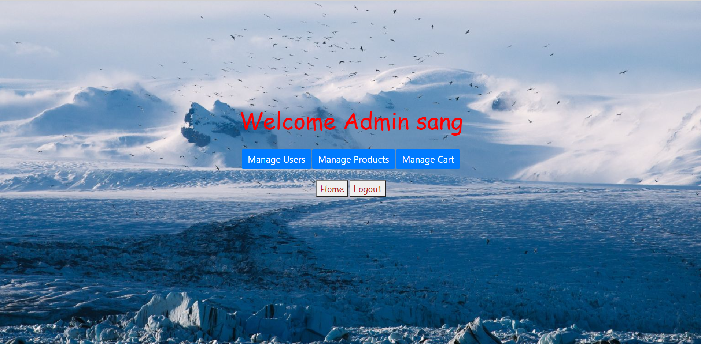

**Admin Page**

* If user is Admin – They have 3 choices are: Manage Users, Manage Products, Manage Cart
* Back to home or logout

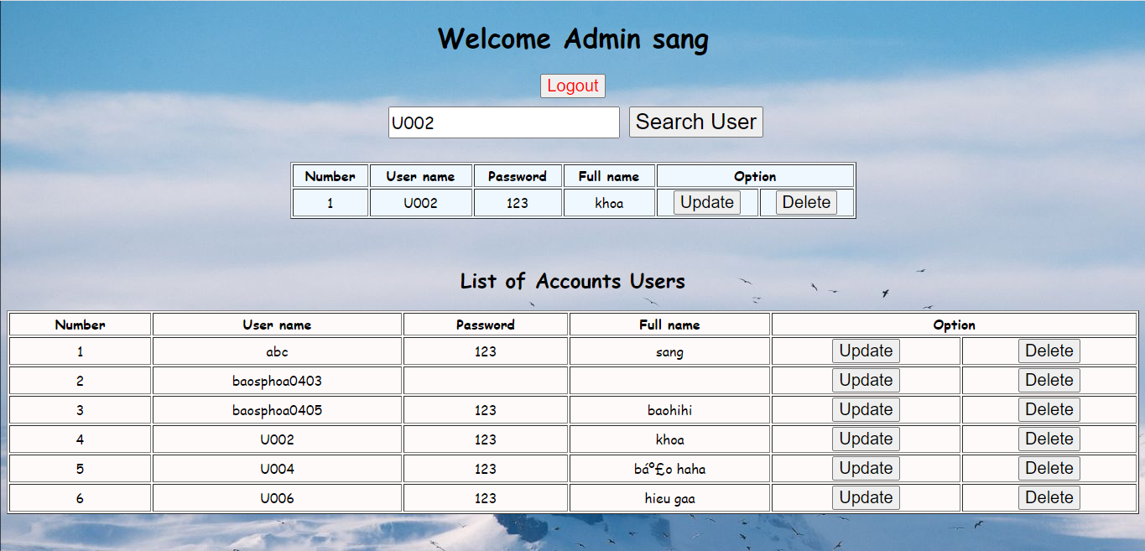

**Manage User**

* Admin can get all information of list Account Users
* Admin can search information of User by Username
* Admin have permission to update or delete Users

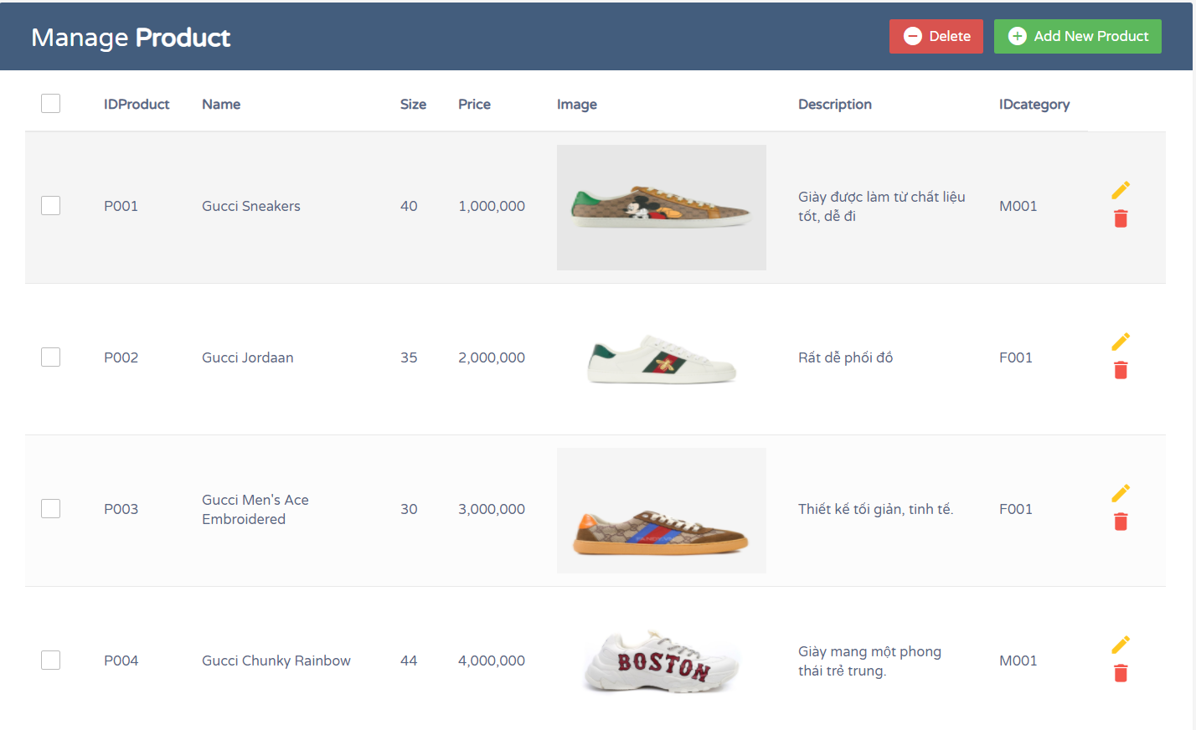

**Manage Product Page**

* Admin get all information of Product
* Admin can Add New Product into database
* Admin can Delete or Update Product

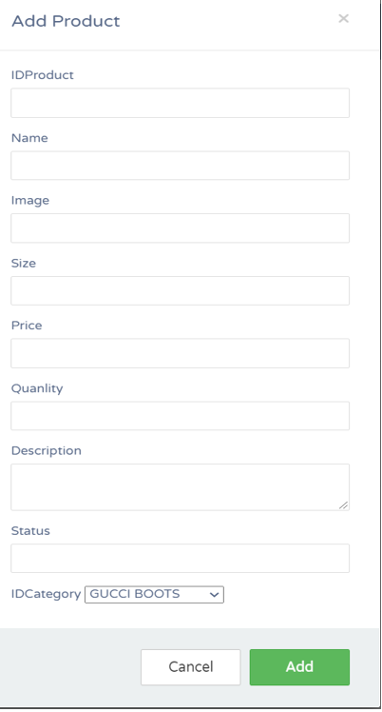

**Add Product Form**

* Admin can add new product to database

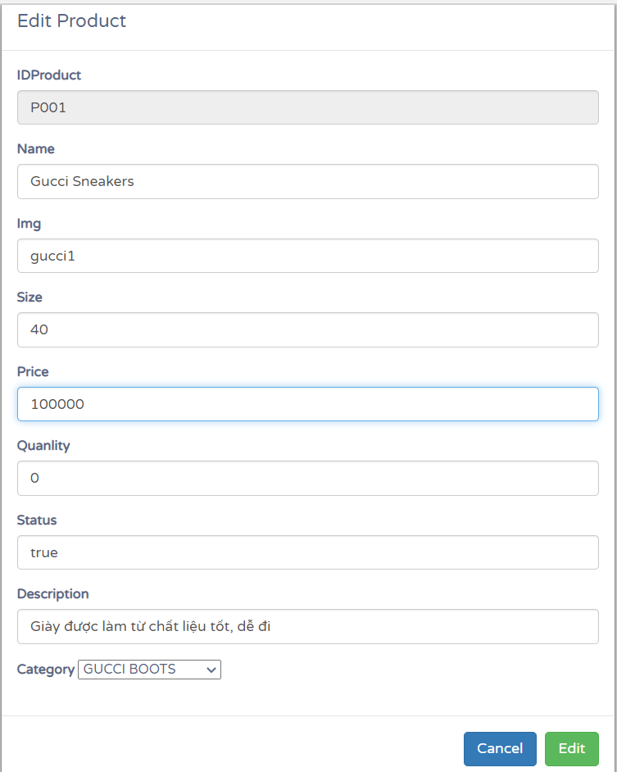

**Edit Form**

* Admin can update fields in Edit Form except IDproduct

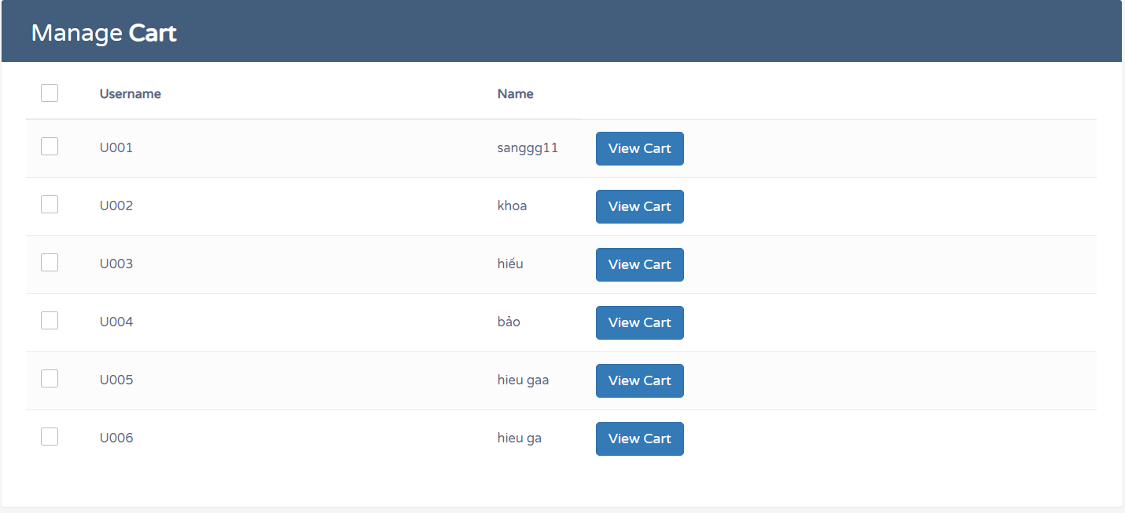

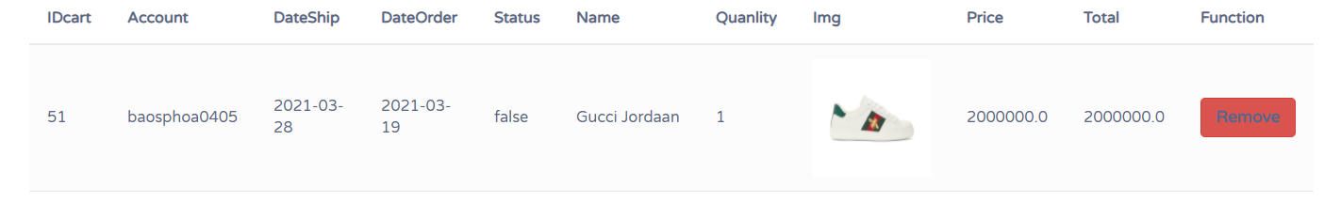

**Manage Cart Form**

* Admin can View Cart and Delete of list Users

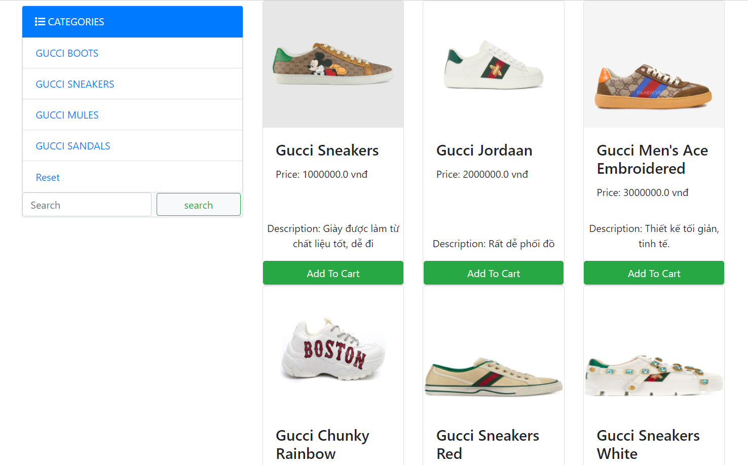

**Customer’s Layout**

* User can view all list products in home page
* User can search by IDCategory to check products
* User can buy product when click button “ Add To Cart “

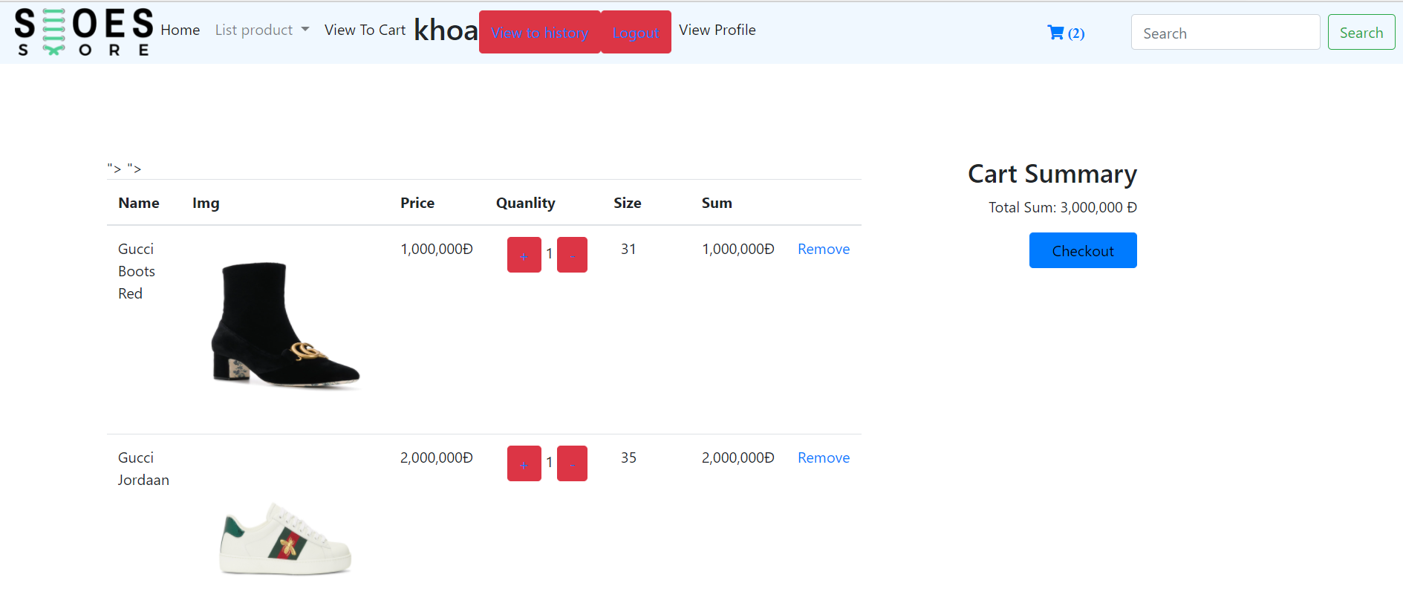

**Add To Cart Form**

* User have permission to Remove Or Checkout Products

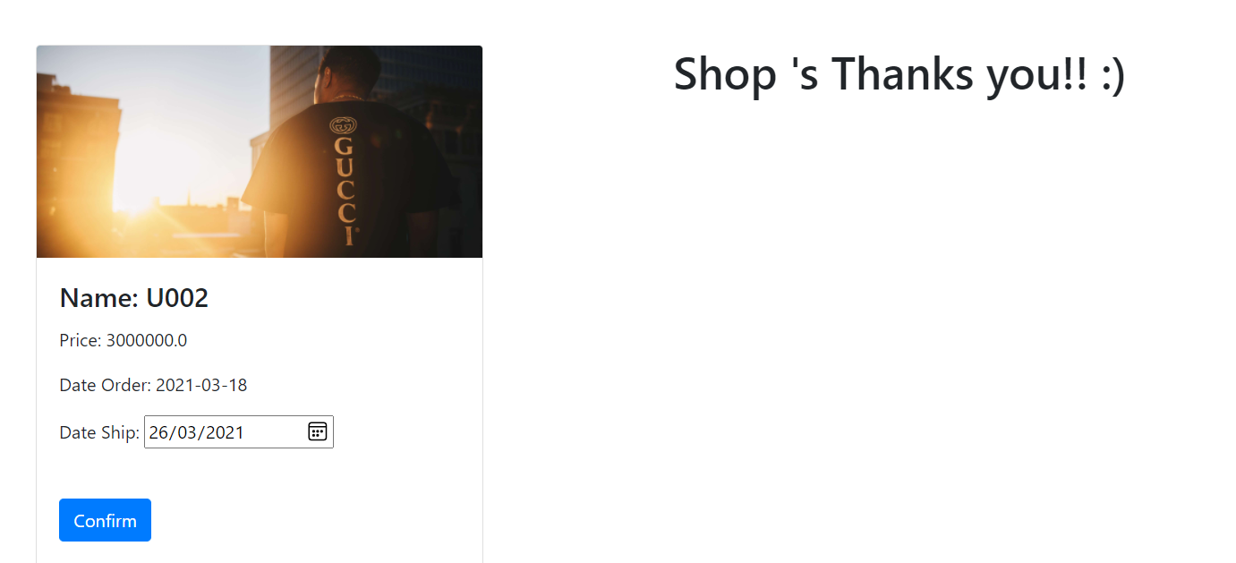

**Confirm Order Page**

* User have permission to check Price,Data Order, Date Ship
* Confirm them if it is true

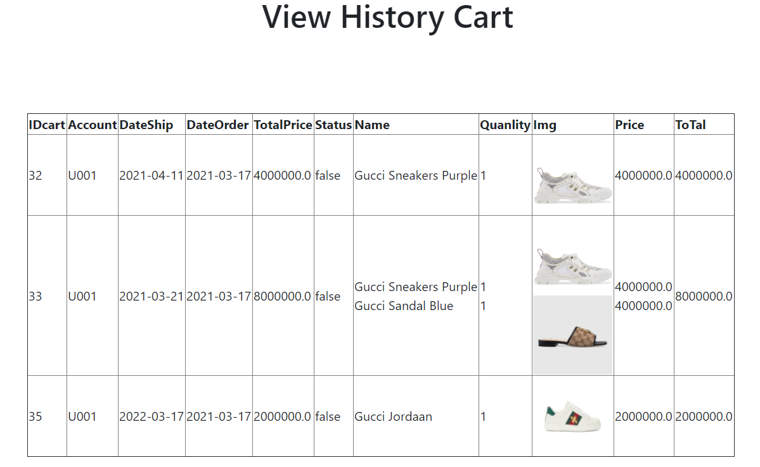

**View History Cart**

* User can check history cart

# Conclusion

We provide users with the basic features such as: add, find, delete, edit. In addition, on the part of users, we add additional features such as purchase order confirmation, purchase history statistics. As for administrators, we add the following features: user management, product management, and purchase order management. The administrator can add, search, delete, and modify in the above functions

# References

[1]. <https://docs.oracle.com/cd/B14099_19/web.1012/b14017/filters.htm>

[2]. <http://docs.oracle.com/javase/tutorial/JDBC>